**Vocabulary list**

a castle – zámek a swimming pool – koupaliště

a church – kostel a hotel – hotel

a restaurant – restaurace a museum – muzeum

a car park – parkoviště a hospital – nemocnice

a train stop/train station – železniční zastávka a post office – pošta

**GIVING DIRECTIONS**

1. **Match the words with the map symbols./ Spoj obrázek se správným názvem.**

**Example:** a swimming pool

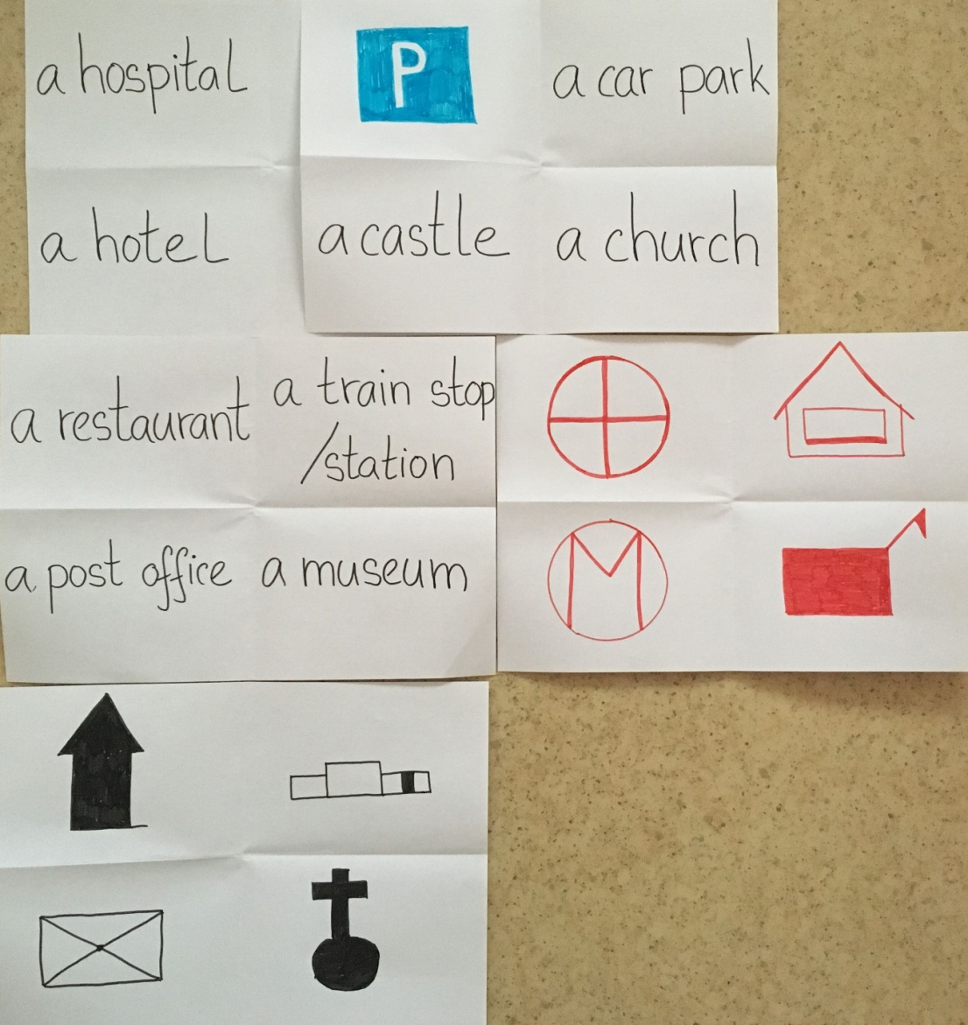

**Vocabulary list - directions**

  

**Turn left**

**Go straight**

**Turn right**

**Crossroads**

**Go along**

**2. Draw the route. You can draw a small map./ Zaznamenej cestu. Nakresli si mapku jako vidiš v příkladu.**

|  |  |
| --- | --- |
| Example: | A: “Excuse me, where is **the post office**?” |
|  | B: “**Go straight**, **turn right** and **go straight**. **Turn left** and **go straight**. The post office is **on the right**. |

**Post office**

**A**

|  |  |
| --- | --- |
| Example: | A: “Excuse me, where is **the bank**?” |
|  | B: “**Go along** this street**, then** **turn left** **at the crossroads** and **take the first street** **on the right** |

|  |  |
| --- | --- |
| Example: | A: “Excuse me, where is **the museum**?” |
|  | B: “**Go straight, turn left and go straight. Then turn right and go straight. Turn right** and the museum is **on the left side.** |

**3. Can you see yourself in the map? Describe the way to the restaurant. /Vidíš, kde stojíš? Popiš cestu do restaurace.**

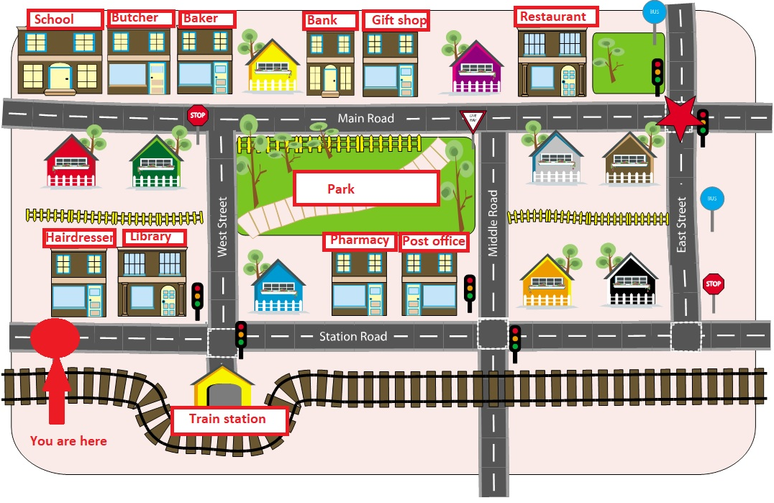[1]

____________________________________________________________________________________________________________________________________________________________________________________________________________________________________________________________________________________________________________

**4. Draw your map and three map symbols in it. Tell your friend some directions. He/she can draw a route. /Nakresli vlastní mapu. Vyber si tři mapové značky a zakresli je do své mapy. Vymysli cestu pro svého kamaráda. Zvládne ji zakreslit?**

1. https://en.islcollective.com/resources/printables/worksheets_doc_docx/give_and_follow_directions_on_a_map/prepositions-giving-directions/50367