 | pizza |  | pineapple
 | hamburger |  | carrot
 | pear | 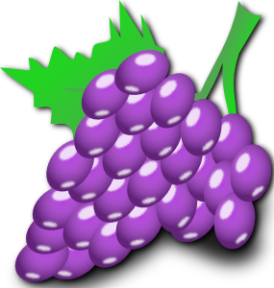 | grapes
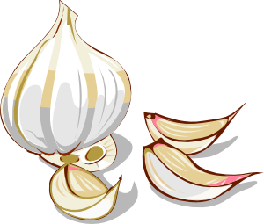 | garlic |  | ice cream
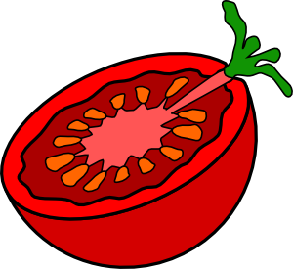 | tomato |  | cheese
 | egg | 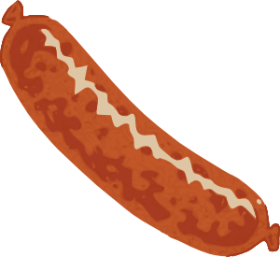 | sausage
 | chicken | 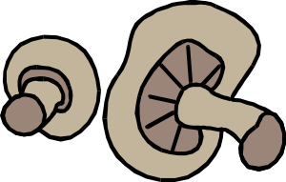 | mushrooms
 | onion | 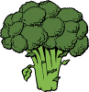 | broccoli

Všechny uveřejněné odkazy [cit. 2011-08-18]. Dostupné pod licencí Public domain na WWW:

<http://www.clker.com/clipart-2018.html> – pizza
<http://www.clker.com/clipart-4079.html> – hamburger
<http://www.clker.com/clipart-3998.html> – pineapple
<http://www.clker.com/clipart-10133.html> – carrot
<http://www.clker.com/clipart-3995.html> – pear
<http://www.clker.com/clipart-13388.html> – grapes
<http://www.clker.com/clipart-4102.html> – garlic
<http://www.clker.com/clipart-4131.html> – ice cream
<http://www.clker.com/clipart-9654.html> – tomato
<http://www.clker.com/clipart-cheese-1.html> – cheese
<http://www.clker.com/clipart-14100.html> – egg
<http://www.clker.com/clipart-14250.html> – sausage
<http://www.clker.com/clipart-25852.html> – chicken
<http://www.clker.com/clipart-29015.html> – mushrooms
<http://www.clker.com/clipart-52554.html> – onion
<http://www.clker.com/clipart-29024.html> – broccoli

